CaseManagement_CreationOfCase_Instance23_03-Aug-2018_04-57-11_AM_MouseClickActionMoveToElementBycssSelectorspanTabSFA.png

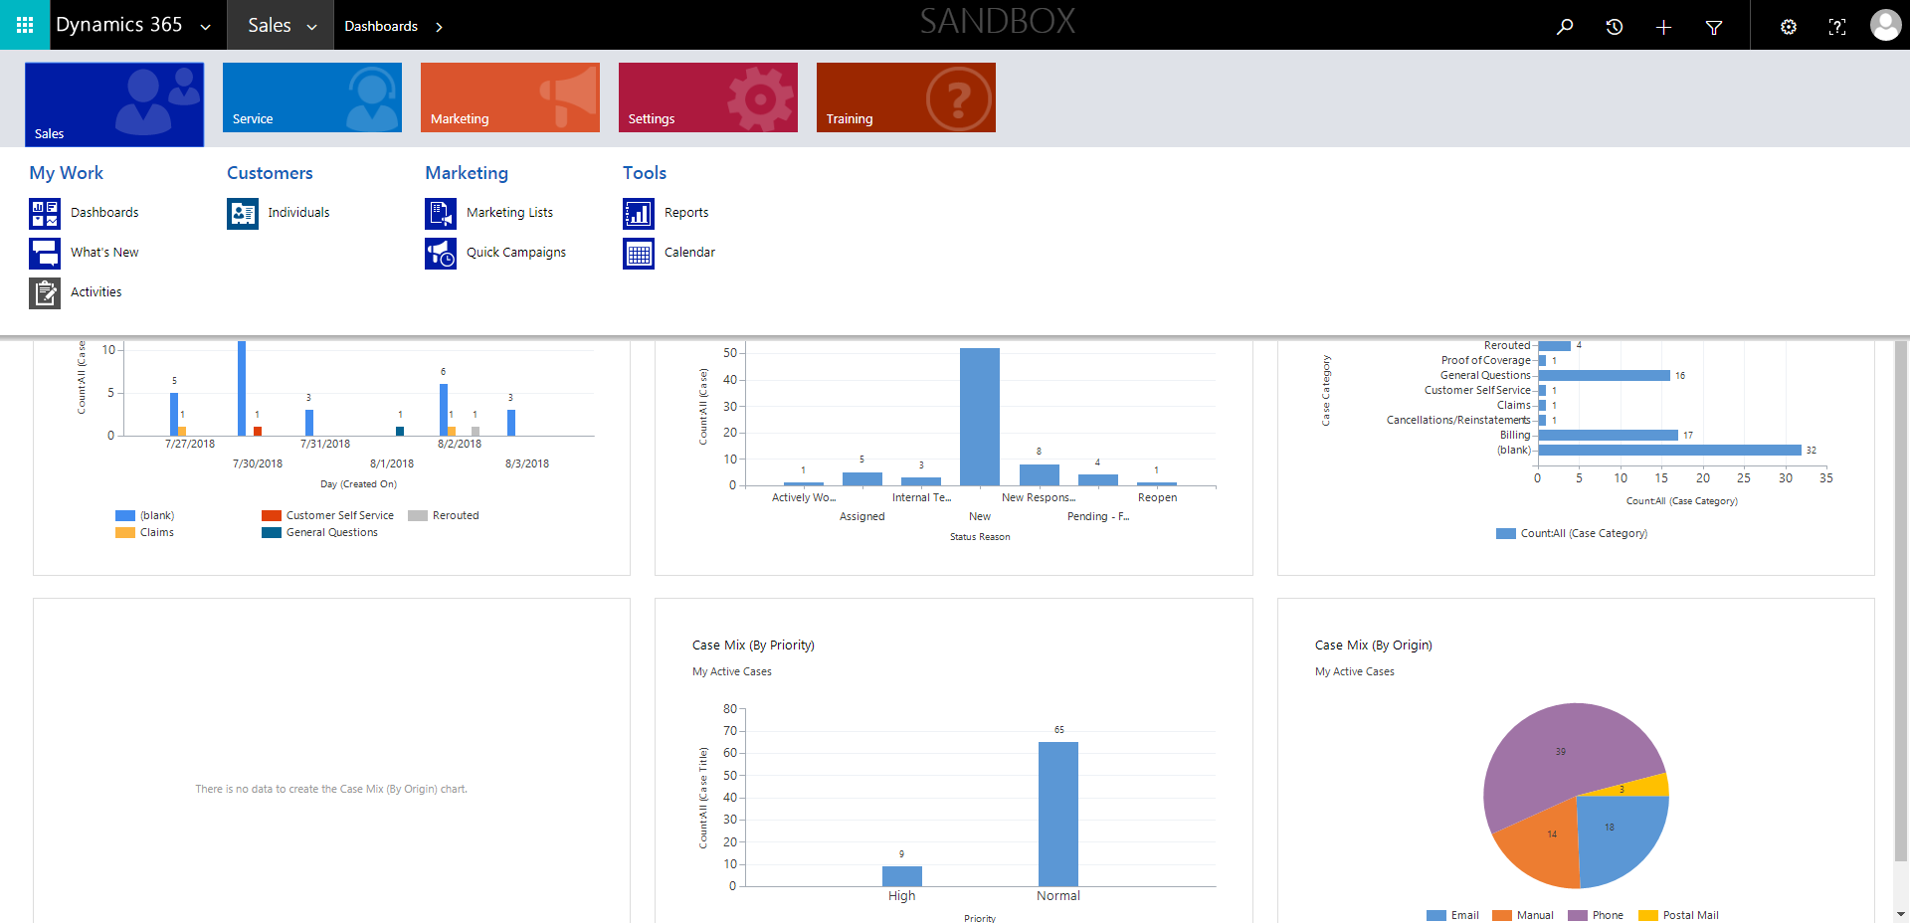

CaseManagement_CreationOfCase_Instance23_03-Aug-2018_04-56-31_AM_MouseClickActiononStaleElement.png

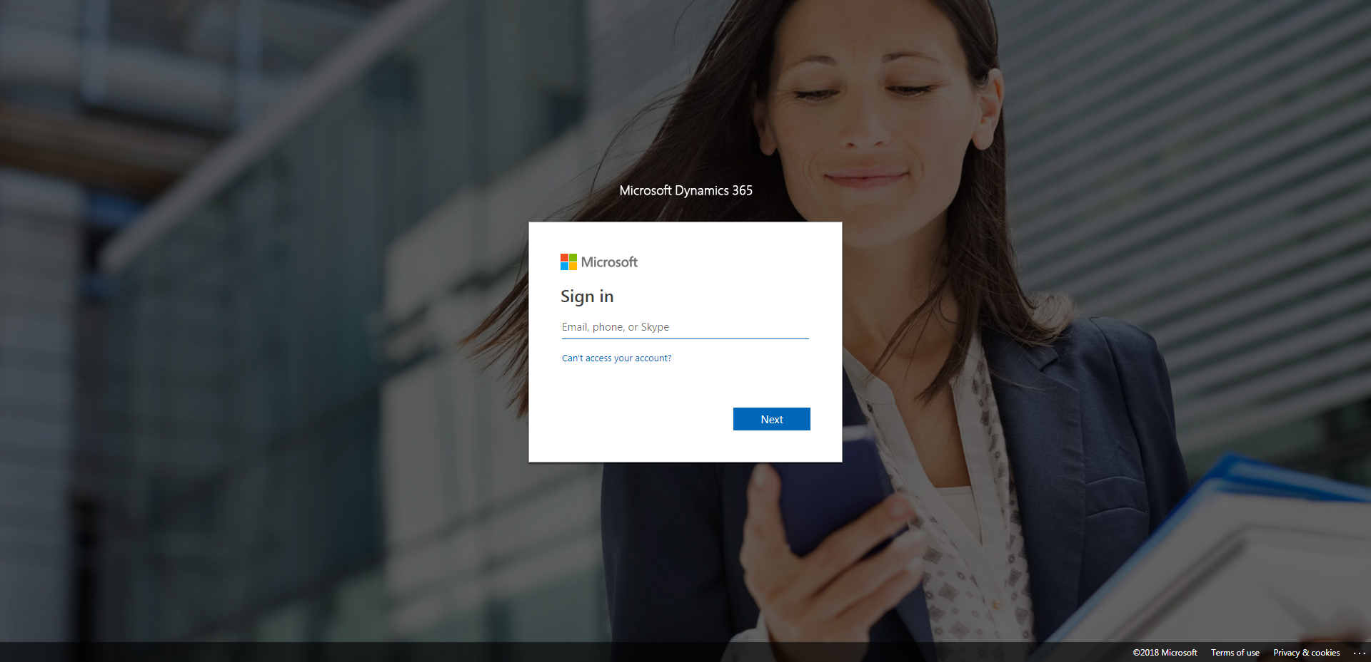

CaseManagement_CreationOfCase_Instance23_03-Aug-2018_04-57-18_AM_MouseClickActionMoveToElementBycssSelectoranavcases.png

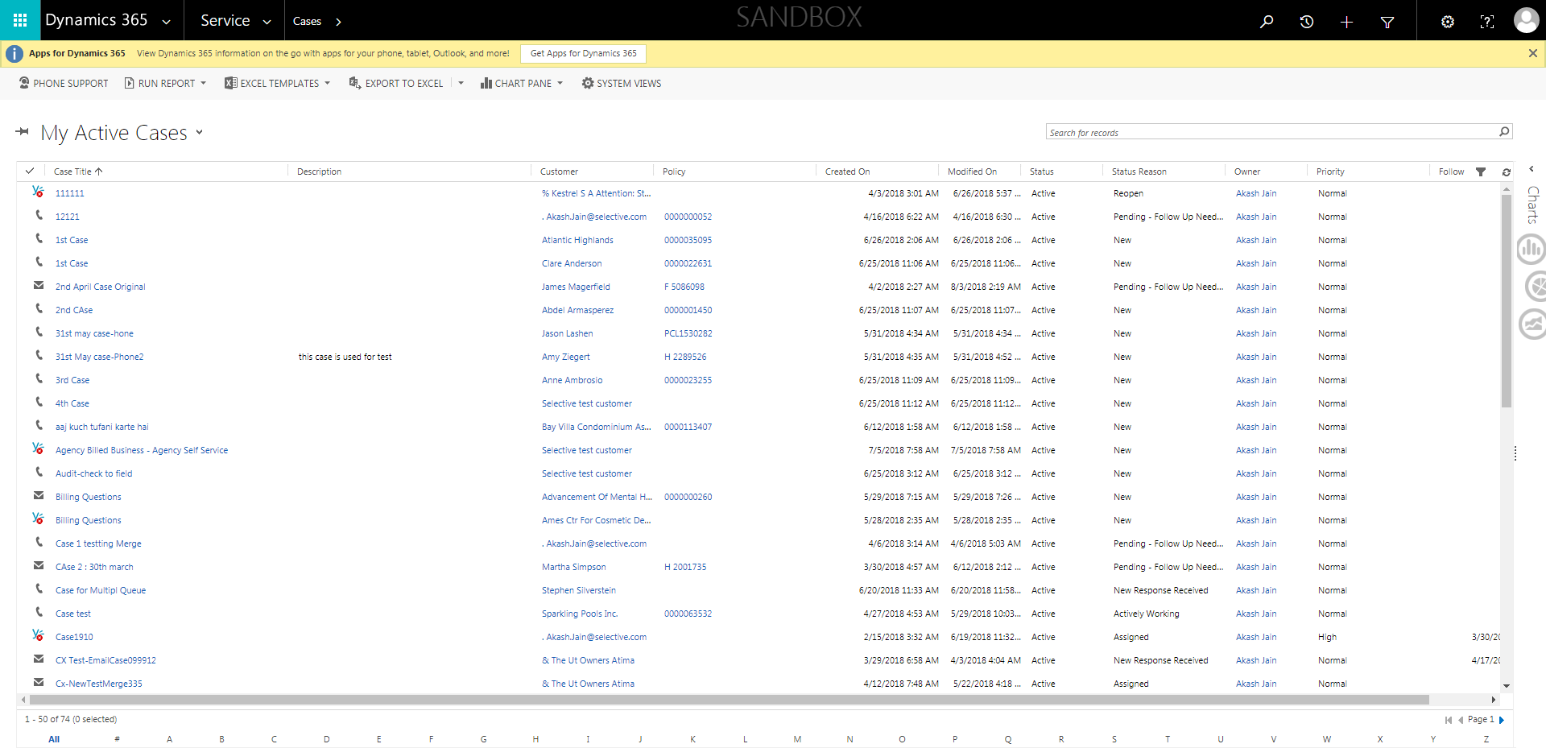

CaseManagement_CreationOfCase_Instance23_03-Aug-2018_04-57-17_AM_MouseClickActionMoveToElementByxpathimgaltServiceparentspan.png

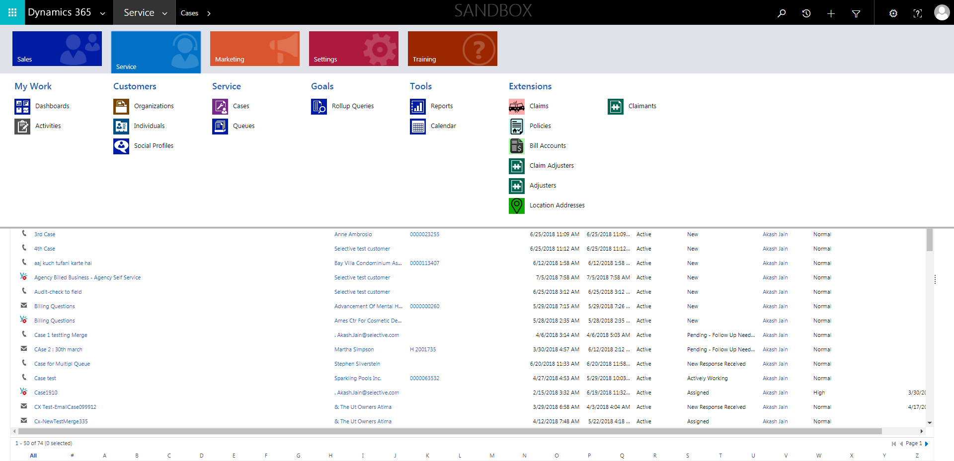

CaseManagement_CreationOfCase_Instance23_03-Aug-2018_05-03-56_AM_VerifyNewCaseCreationHouronCaseisinEasternTime.png

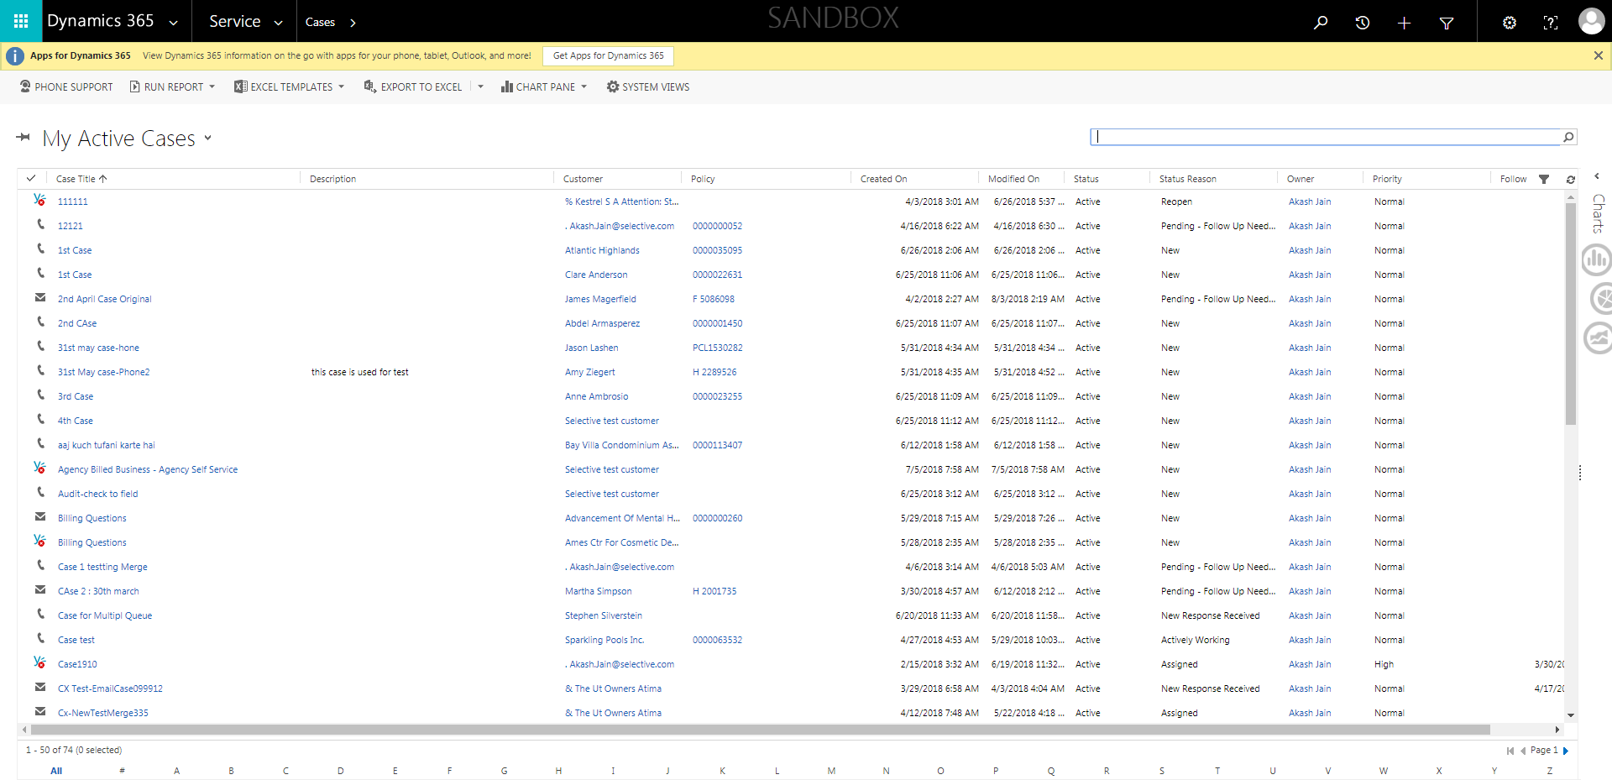

CaseManagement_CreationOfCase_Instance23_03-Aug-2018_04-57-11_AM_MouseClickActionMoveToElementByxpathimgaltServiceparentspan.png

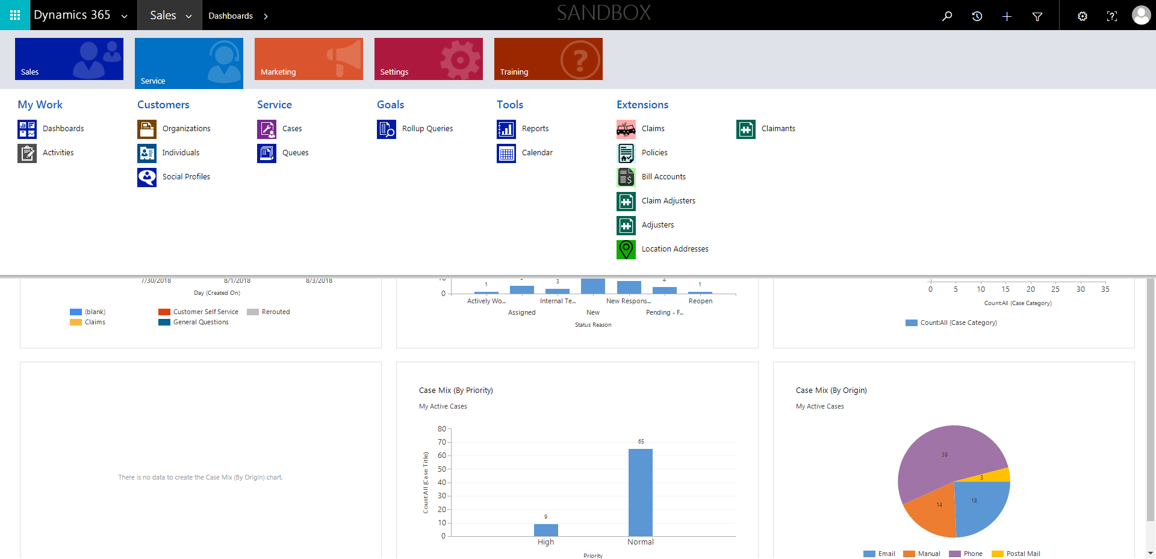

CaseManagement_CreationOfCase_Instance23_03-Aug-2018_04-56-58_AM_SingleSignOn.png

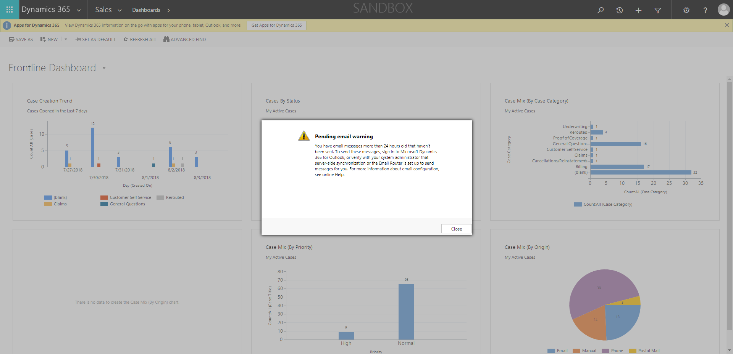

CaseManagement_CreationOfCase_Instance23_03-Aug-2018_04-57-20_AM_ValidatingCaseentitynavigation.png



CaseManagement_CreationOfCase_Instance23_03-Aug-2018_05-00-38_AM_GetTextFromElement.png



CaseManagement_CreationOfCase_Instance23_03-Aug-2018_04-57-07_AM_SingleSignOn.png

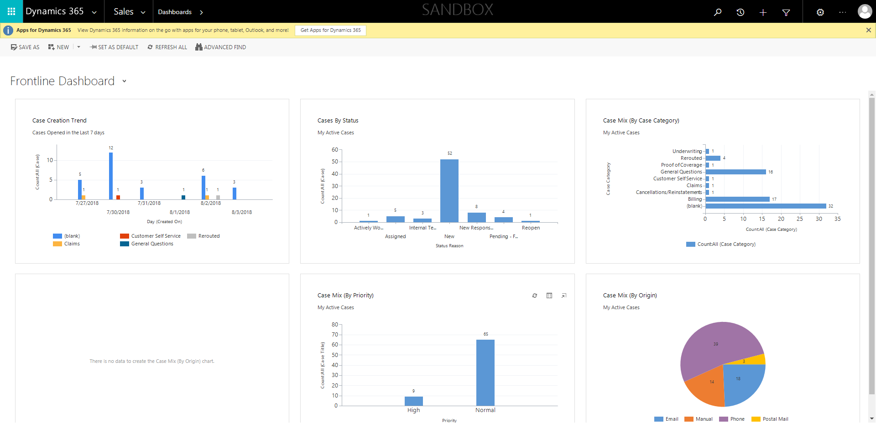

CaseManagement_CreationOfCase_Instance23_03-Aug-2018_04-56-34_AM_MouseClickActiononStaleElement.png

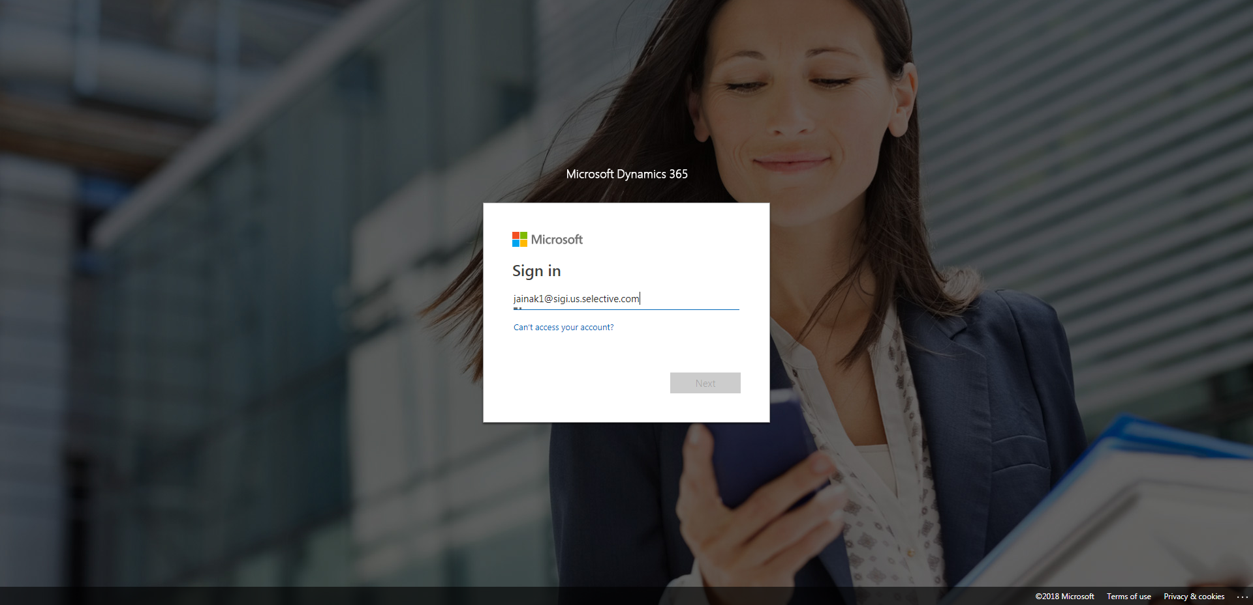

CaseManagement_CreationOfCase_Instance23_03-Aug-2018_05-00-38_AM_VerifyNewCaseCreationHouronCase.png

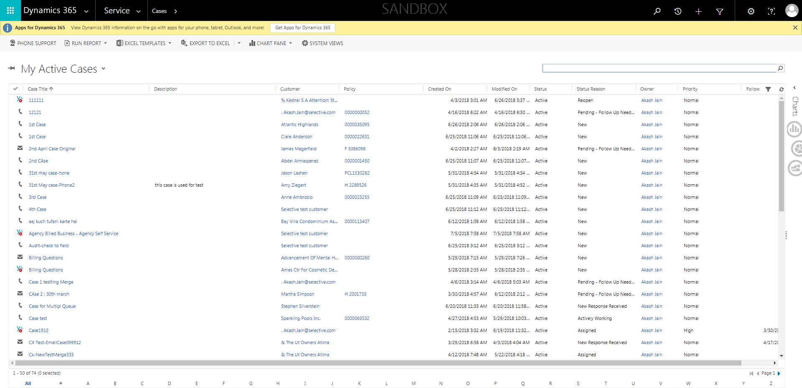

CaseManagement_CreationOfCase_Instance23_03-Aug-2018_04-57-12_AM_MouseClickActionMoveToElementBycssSelectoranavcases.png

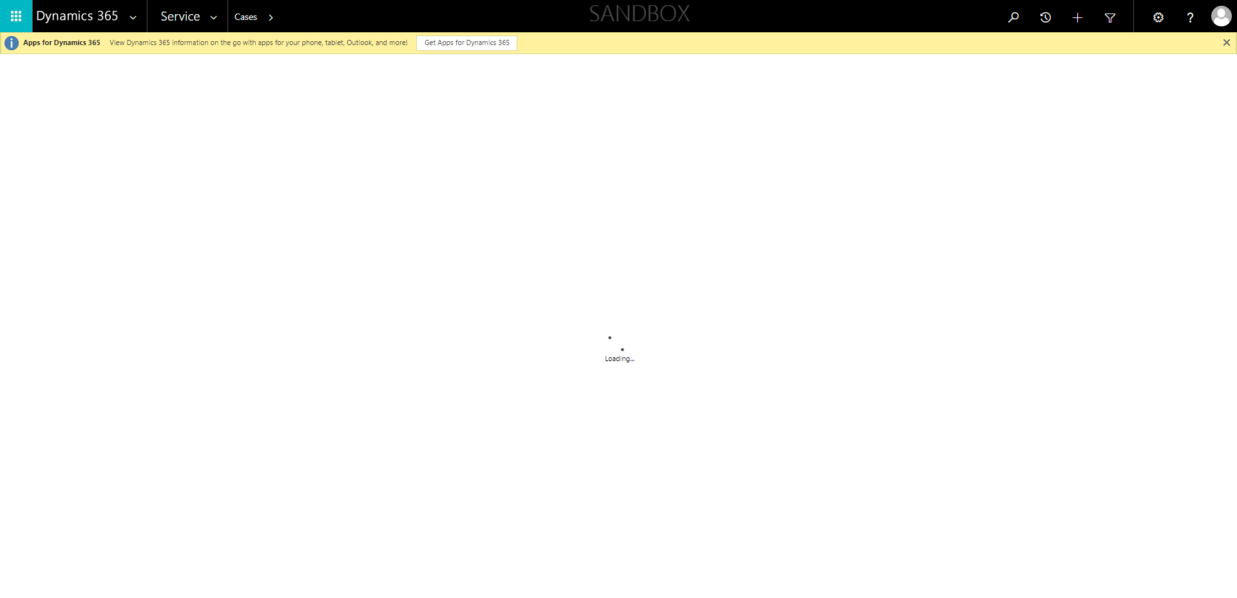

CaseManagement_CreationOfCase_Instance23_03-Aug-2018_04-56-33_AM_EnterTextAction.png

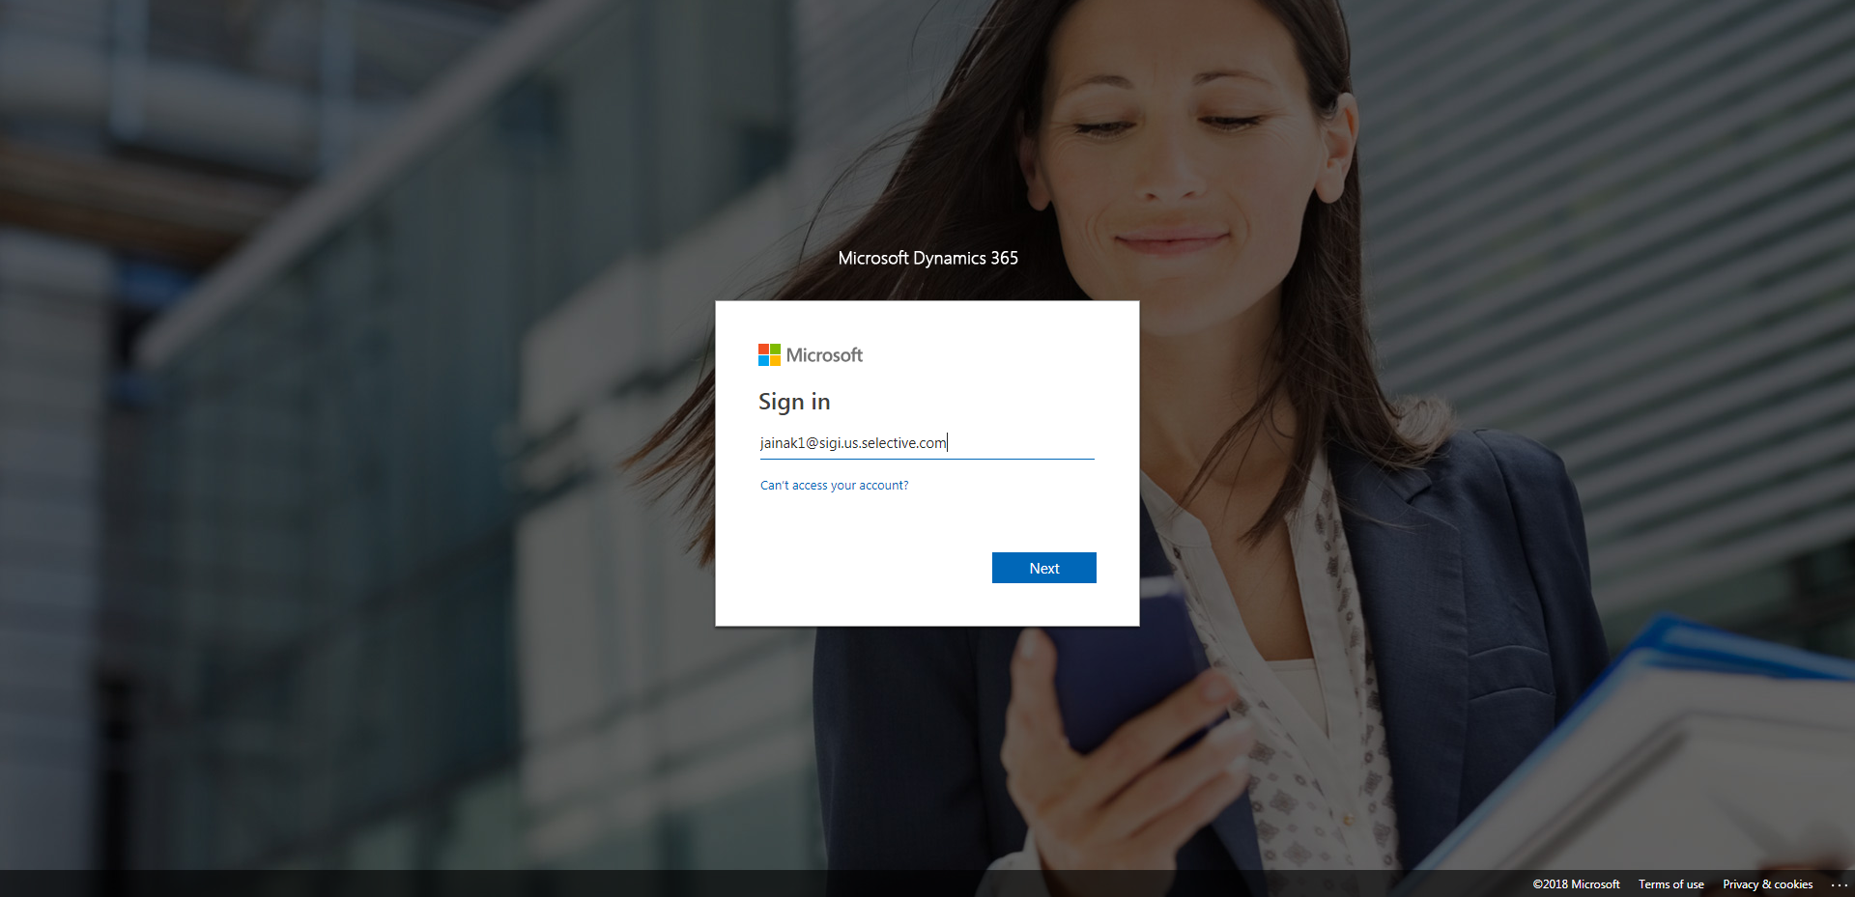

CaseManagement_CreationOfCase_Instance23_03-Aug-2018_04-57-16_AM_MouseClickActionMoveToElementBycssSelectorspanTabCS.png

